ECMA script 2015

European computer manufacturing association

It is just standard, not library not language

Latest is ecma 11 launched in 2021

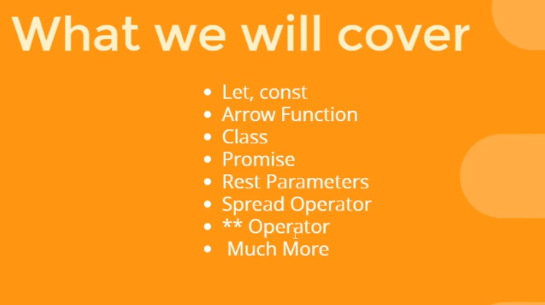

Let keyword –

1)it is use for block scope

2)baher cha madhe access karu shakto pan madhla baher nahi

3)hoisting in – we can’t use hoisting with let , we can use with var

I Q - - - 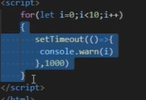

Output – 1)for let – 1,2,3,4,5,6,7,8,9 2) for var – 10

2)Default parameters in function –

Can we pass function as parameter?

Ans - yes

3)template literals

1)use backtiks – for lengthy lines

4)find and findindex –

Find – nearest but only one value

findindex -will give position in array

5) arrow function in details

This keyword -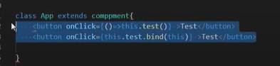

Regular function – swatacha this asat tyamule parent chya this la bind karva lagat use karnyaadhi

Arrow function – swatacha this nasacha,tyamule direct parent cha this use karat

6)classes – introduce in es6

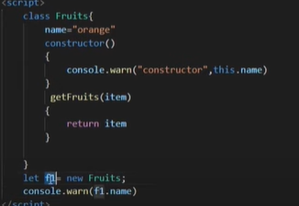

7)Inheritance - introduce in es 6

Properties transfer from parents to children

Super() == parent class ke constructor ko call karne ke liye use karte hai

Can we use child function in parent?

Ans= no

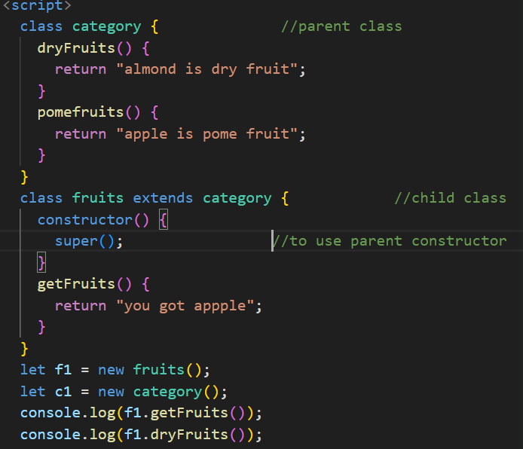

8) lexical scope – kiska kitna scope hai

If we use function in function then ‘this ‘will refer to different parent function at different position.

We use arrow function to resolve this.

9)rest parameter

What? Ans – baki ki bachi hui chize,

When? Ans – jab hame pata nahi hota ki function me kitne parameter hai tab use karte hai

Syntax - …

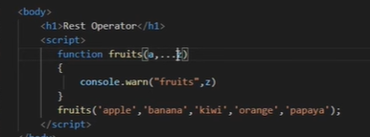

Tip - - rest operator must be last in row.

10)Promise in ES6 –promise tab execute hota hai jab pura code run ho chuka hota hia

Problem -Js is async lang that why it ignore code which takes time and move on to next one

11)new global function –

1) isFinite – number ani null asel tr true return karel

2)isNan – jab number nahi hoga

12)Destructuring of array –

Def – unpacking of array into variables

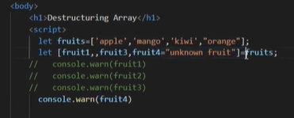

13) Destructuring of object

Diff – array madhe index and object madhe keys chya basis var destructring karto

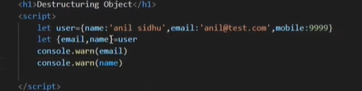

14)spread operator - -

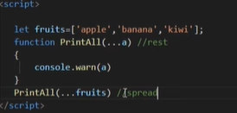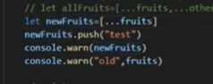

rest operator puts the rest of some specific user-supplied values into a JavaScript array. But the spread syntax expands iterables into individual elements.

15)Exponentiation operator—



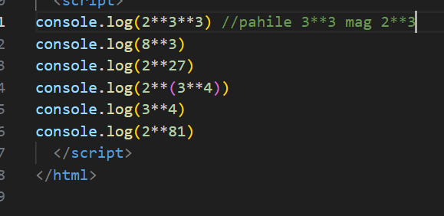

16)Module –

What? Ans- ek file ke kuch code ko dusre file me use kerne ko

Jevde pahije tevdecha module/function/variable import karayche

Import export

Default - use nahi kare to {} dene padenge

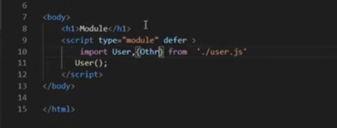

17)Generators –

Function hi hote hai par hum isse pause aur resume kar sakte hai like movie

Yield – as breaker,to make steps

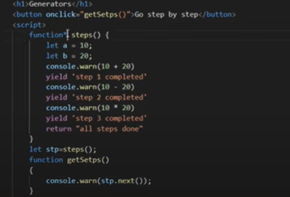

Rest api……………